DECLARATION

I, Nsalar Lydiana Malah, registration No; UBa21PH027, in the department of Computer Engineering, College of Technology, the university of Bamenda, hereby declare that the project titled “Control Of House Appliances Using Android” has been undertaken and completed by me.

‘

CERTIFICATION

This is to certify that the project title “the control of house appliances using android” has been fully completed by Nsalar Lydiana Malah. The project was undertaken as part of the Bachelor of technology in Computer Engineering at COLTECH (College of Technology) in the university of Bamenda, Cameroon.

Supervisor: _____________

Mr. Mbathieu Cezar

Examiner: _______________

Head of department: ___________

Dr. Suh Charles Forbacha

ABSTRACT

In our world today, many homes use traditional methods to control their house appliances. These traditional methods have relied of manual interactions through physical switches and buttons. Individuals physically operate switches to press buttons located on their appliances themselves or on nearby walls. This direct interaction allows for simple immediate control over specific functions such as turning appliances on or off, adjusting settings, or activating different modes. Individuals find this very difficult and stressful at times especially in situations where there was no electricity and you might have forgotten your appliances on and you are not home at the moment. This becomes stressful and very costly as you have to go back home before switching them off. Also individuals find difficulty when they have children at home and they might forget to check appliances before leaving home or going to bed, or when the children use appliances when they are supposed to.

It was on such a background that researchers embarked on a project to implement a system that enables individuals to control their house appliances using the android.

DEDICATION

This project is dedicated to my father Mr. Nsalar Fidelis with utmost love and gratitude. Your unwavering support, guidance, and encouragement have been my inspiration throughout this academic journey.

# ACKNOWLEDGEMENT

* I sincerely thank the central university Bamenda and all its staff for giving me this opportunity through the knowledge I acquired from them through education.
* I equally thank my project supervisor Mr. Mbathieu Cezar for his guidance through encouragement and advice which gave me inspiration and team spirit which actually contributed a lot in the successful completion of my project.
* I equally express my sincere gratitude to my most beloved father MR. NSALAR FIDELIS who stood by me to encourage, guide and support me morally and financially throughout my studies in school till the completion of my final year project
* My special thanks also go to all my family members who stood by me with encouragement and support of any form just to see me through.
* More so, I greatly appreciate the company of my friends and class mates in school and at home who motivated, encouraged and assisted me in one way or the other.
* And most importantly, I offer the greatest thanks and acknowledgement to the ALMIGHTY GOD for the gift of life, my family, friends, mate and teachers, for his watch over me throughout my project, and his guidance and protection over us all.

Table of content

List of figures

List of abbrievations

CHAPTER ONE

INTRODUCTION

The control of house appliances using android is an innovative project that aims to enhance the convenience, energy efficiency, and enhanced the control over the household devices. By enabling android application, users can effortlessly manage multiple appliances from anywhere within the Wi-Fi network’s range. This project promotes accessibility, cost savings, and automation possibilities, aligning with the technological advancements of smart homes and contributing to a more sustainable and connected living environment.

* 1. Background of study

In the past, the control of house appliances relied heavily on manual and physical interactions. Individuals were required to physically opetate switches, knobs, or buttons on the appliances themselves or on nearby walls to control their functionalities. This manual approach allowed for basic control but often resulted in inconveniences and limitations.

Controlling house appliances manually and physically presented several challenges. Firstly, it required individuals to be physically present in close proximity to the appliances, which restricted flexibility and convenience. For instance, having to walk to different areas of the house to operate multiple appliances could be time-consuming and tiring.

Additionally, managing multiple appliances simultaneously became a cumbersome task. Each appliance typically had its own set of controls making it difficult to coordinate and synchronize their operations. This lack of centralized control resulted in inefficiencies and potential user errors.

The advent of technology brought about a significant advancement in the way house appliances are controlled. The introduction of remote control devices, such as handheld remotes enabled users to operate their appliances from a distance within the home. However, remote control still required users to keep track of multiple devices and often had limited communication ranges which brought the idea of using the mobile android to bridge those limited communication ranges.

* 1. Problem statement

The traditional, manual and physical control of house appliances possess several challenges, including limited convenience, lack of centralized control and inefficient management of multiple appliances. These limitations result in increased stress and inconvenience for users. Therefore, there is a need to explore and implement more efficient and user-friendly approach to control house appliances, leveraging the capabilities of android technology. The problem to be addressed in this this project is to develop a system that enables users to remotely and seamlessly control their house appliances using android devices, eliminating the physical constraints and enhancing the overall control experience.

* 1. Research question and objectives
     1. Problem Questions
* How does android-based control system compare to the current methods and technologies used for the control of house appliances in terms of functionality, usability and convenience?
* How can the android application effectively communicate and interact with different types of house appliances?
* How does the integration of smart home technologies and internet of things (IoT) devices impact the functionality and capabilities of an android app for controlling house appliances?
  + 1. Objectives

Main objective

To develop a system that allows users to remotely control various household appliances using an android device such as a smart phone.

Specific objectives

* Developing an android application with a user-friendly interface for controlling and monitoring house appliances.
* Establishing communication protocol between the android device and the appliances, enabling seamless interaction.
* Providing documentation and user guides to assist users in setting up and using the android application to control their house appliances effectively.
  1. Rationale
     1. Justification and motivation

This project is justified by its ability to provide users with convenience, energy efficiency and enhanced control over their household devices. By enabling the control through android application, users can effortlessly manage multiple appliances from anywhere within the Wi-Fi network’s range. This project promotes accessibility, cost savings and automation possibilities, aligning with the technological advancements of smart homes and contributing to a more sustainable and connected living environment

* + 1. Significance of Study

The control of house appliances has several significant advantages:

* Convenience: One of the key benefits of controlling house appliances using Android is convenience. With an android device such as a smart phone, you can remotely operate and manage your appliances from anywhere within the range of your home’s Wi-Fi network.
* Energy efficiency: Android-controlled appliances can contribute to energy efficiency and cost savings. You have better control of their usage and can optimize energy consumption. For instance, you can turn off lights when you are not using them.
* Remote monitoring: With the android, you can monitor your house appliances remotely. You can check the status of your appliances.
* Accessibility and assistive technology: Android-controlled appliances can greatly benefit individuals with disabilities or limited mobility.
* Enhanced Security: Android-based control systems often come with advanced security features. They typically incorporate encryption protocols and secure communication channels to protect your data and prevent unauthorized access.
  1. Scope and limitations of study
     1. Scope

The study is detailed about designing a mobile application, establishing a Wi-Fi connection between the application and various house appliances.

* + 1. Limitations
* Limited range: Wi-Fi connections typically have limited range and when controlling house appliances, it is necessary to be within the range of the Wi-Fi network.
* Power outages and internet disruptions: When power goes out or there are internet disruptions, the connectivity and control of house appliances will be affected
* Compatibility with appliances: Not all house appliances have necessary connectivity options to integrate with the app.
* Scalability and complexity: As the number of appliances and functionalities increase, the complexity of the project also grows

CHAPTER TWO

LITERATURE REVIEW

2.1 Introduction

The control of house appliances using android devices has emerged as an area of significant research and development. The proliferation of smartphones and the advancements in mobile technology have paved the way for convenient and remote control of various devices within the home environment. The evolution of android operating system and its widespread adoption have played a crucial role in enabling this control mechanism.

The concept of controlling devices using android devices originated from the increasing desire for automation and smart home solutions. Researchers and developers recognized the potential of leveraging the capabilities of smartphones to create a centralized control system for house appliances. This led to the development of android applications specifically designed to communicate with and control a wide range of devices such as lights, security systems, and entertainment devices.

One of the key factors that contributed to the popularity of controlling devices using android is the ubiquitous nature of smartphones/ with the increasing number of smartphone users globally, android-based control systems provide a convenient and familiar interface for users to interact with their appliances. The touch screen capabilities, intuitive user interfaces, and widespread availability of android devices make them an ideal platform for controlling devices within the home.

The rise of Wi-Fi connectivity has also been instrumental in enabling the control of devices using android. By leveraging Wi-Fi networks. android devices can establish a reliable and seamless connection with appliances, allowing for real-time communication and control. Users can remotely operate their devices from anywhere within the Wi-Fi network’s range, providing a new level of flexibility and convenience.

Security considerations have also played a significant role in the development of android-based control systems. Researchers have focused on implementing robust security measures to protect against unauthorized access and ensure the privacy of users’ data. Encryption protocols, authentication mechanisms, and secure communication channels have been explored to establish secure connections between android devices and appliances.

The drive for energy efficiency and sustainable living has influenced the development of android-based control systems. Researchers have investigated energy optimization techniques, such as scheduling, power monitoring and intelligent automation, to enable users to manage their devices efficiently and reduce energy consumption. This not only helps users save on energy costs but also contributes to environmental conservation.

The control of house appliances using android devices has emerged as a result of the increasing demand for automation, convenience, and energy efficiency. The combination of smartphone ubiquity, Wi-Fi connectivity, security measures, and the desire for sustainable living has driven the development of android applications specifically designed for devices control. This project aims to contribute to this field by developing a robust and user-friendly android-based control system for various appliances

2.2 Brief history and overview of Android application development for home automation and appliance control

Android application development for appliance control has evolved significantly over the years, revolutionizing the way we interact with household devices. Initially, developers focused on creating standalone applications for specific appliances, allowing users to control them remotely using their android devices. However, the ecosystem was fragmented, with different manufacturers requiring separate applications.

As communication protocols like Wi-Fi and Bluetooth became more prevalent, android-based appliance control expanded. These protocols enabled seamless connectivity between android devices and appliances, fascinating real-time communication and control.

The introduction of home automation platforms and frameworks, such as google home and amazon Alexa, provided a unified ecosystem for integrating and controlling a wide range for devices through android applications. User interface design and usability also improved, with developers creating intuitive interfaces and incorporating features like scheduling and automation.

The integration of voice control and artificial intelligence further transformed android-based appliances control. Users can now interact with their devices using voice commands, leveraging technologies like natural language processing and machine learning.

Android application development for appliance control has progressed from fragmented standalone applications to unified and user-centric solutions. Advancements in connectivity, user interface design angd voice control have made android the go-to platform for managing appliances in modern smart homes.

2.3 Wi-Fi connectivity and protocols for smart home applications

Wi-Fi, also known as wireless fidelity, is a wireless communication technology that allows devices to connect and exchange data over a local area network (LAN) or the internet. It has become ubiquitous in modern homes, providing a reliable and high-speed wireless connection.

In the early 2000s, Wi-Fi technology began to be adopted for home networking, enabling the connection of computers, laptops and other devices to the internet without the need for wired connections. This laid the foundation for the integration of Wi-Fi into smart home applications.

The development of Wi-Fi protocols specifically tailored for IoT and smart home applications has been instrumental in enabling seamless communication between devices. Some key Wi-Fi protocols used in smart home applications include:

1. Wi-Fi Direct: this protocols allows devices to establish a direct connection with each other without the need for a traditional Wi-Fi access point. It enables devices to communicate and share data directly, making it suitable for peer-to-peer communication between the smart home devices.
2. ZigBee: While not strictly a Wi-Fi protocol, ZigBee is a wireless communication standard commonly used in smart home applications. It operates on low-power wireless networks and is designed for short-range communication between devices. ZigBee is known for its low energy consumption and mesh networking capabilities, making it ideal for smart home environments.
3. Z-wave: Similar to ZigBee, Z-wave is a wireless communication protocol designed for home automation and smart home applications. It operates on low-power radio frequencies and offers a mesh network topology, allowing devices to communicate with each other and extend the network’s range.
4. Thread: Thread is an IP-based wireless networking protocol designed for smart home applications. It leverages the IPv6 protocol to enable secure and scalable communication between devices. Thread is known for its low power consumption, reliability, and support for large networks.

These Wi-Fi protocols, along with advancements in security mechanisms and encryption protocols, have paved the way for secure and reliable communication between smart home devices. They enable devices to connect to a central hub or directly to each other, allowing for seamless control and automation within the smart home ecosystem.

2.4 The integration of appliances with control systems

The integration of various appliances with control systems has revolutionized the way we manage and control our household devices.

Integration of appliances with control system involves connecting and synchronizing different types of appliances to a centralized control platforms or system. This allows users to manage and control multiple appliances simultaneously, often through a single interface or application. The integration process typically involves the following key aspects;

1. Connectivity: Appliances are connected to the control system using various communication protocols such as Wi-Fi, Bluetooth, ZigBee or z-wave. These protocols establish a reliable connection between the control system and the appliances, enabling seamless communication and control.
2. Centralized control: once connected, the control system serves as centralized hub for managing and controlling the appliances. It provides a user-friendly interface that allows users to monitor and control their devices from a single location, such as a smartphone, tablet or web portal.
3. Interoperability: Integration focusses on achieving interoperability between different appliance brands and types. The control system is designed to work with a wide range of appliances, regardless of their manufacturer, allowing users to control diverse devices within their home environment.
4. Functionality: Integrated control systems offer a multitude of functionalities. Users can perform actions such as turning appliances on and off, adjusting settings, setting schedules and monitoring devices status. Advance systems may also support automation, voice control and integration with smart home devices or platforms.

2.4 Security considerations and protocols for android appliance control

Security considerations and protocols are of utmost importance when it comes to android appliance control, as they ensure protection of user data, privacy and the integrity of the connected devices.

1. Secure communication: To ensure secure communication between android device and the appliances, encryption protocols such as Transport layer security (TLS) should be implemented TLS encrypts the data transmitted between the devices, preventing unauthorized access.
2. Authentication and authorization: Proper authentication and authorization mechanisms should be in place to verify the identity of the users and ensure that only authorized individuals can access and control the appliances. This can include password-based authentication, two-factor authentication or biometric authentication.
3. Access control: Access control mechanisms should be implemented to restrict access yo the appliances and their control interfaces. Role-based access control (RBAC) can be employed to assign specific privileges to different roles, ensuring that only authorized users can perform certain actions.
4. Secure APIs: When developing android applications for appliance control. It is essential to use secure APIs (Application Programming Interfaces) that ensures security measures. This includes validating user input, protecting against common vulnerabilities such as SQL injection and cross-site scripting (XXS), and securely handling sensitive data.
5. Network security: Android devices should be connected to a secure and trusted networks, such as encrypted Wi-Fi networks. Public Wi-Fi networks and unsecured connections should be avoided to minimize the risk of data interception and unauthorized access.

2.5 User experience and interface design for controlling appliances through android

User experience (UX) and interface are crucial aspects of controlling appliances through android devices. A well-designed and intuitive interface enhances usability, efficiency, and user satisfaction. Here are the key considerations for UX and interface design in android appliance control:

1. Simplicity and intuitiveness: The interface should be simple, easy to understand, and intuitive for users to navigate. The controls and interactions should be straightforward.
2. Clear visual hierarchy: A clear visual hierarchy helps users understand the structure and organization of the interface. Important controls and information should be visually prominent, while less critical elements should have appropriated visual emphasis. Consistent use of visual cues, such as icons and labels, aids in understanding and navigation.
3. Responsive design: The interface should be designed to adapt to different screen sizes and orientations, ensuring a consistent and optimized experience across various android devices. Responsive design enables users to control their appliances comfortably, regardless of the device they are using.
4. Contextual and relevant information: Displaying relevant information about the appliances such as status, settings enhances the user experience. It provides a sense of control over the appliances.

CHAPTER THREE

MATERIALS AND METHODS

3.1 Project methodology

The project methodology for the control of house appliances using android involves the following steps:

* Plan the project objectives and requirements.
* Set up necessary hardware components.
* Develop and android application for appliance control, considering user interface. design and integration with the hardware components.
* Test the system for functionality, responsiveness and reliability.
* System validation

3.2 Hardware requirements

* Android Device: This can be a smartphone or tablet running an android operating system. It serves as the user interface; it sends commands to the microcontroller
* WI-FI Router: A Wi-Fi router is necessary to establish a wireless network connection between the android device and the appliances. It provides a network infrastructure required for communication.

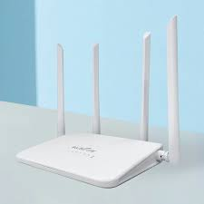

* ESP 32 Microcontroller: It acts as the main control unit for receiving commands from the android device over wifi, processing those commands, and sending them to the Arduino board

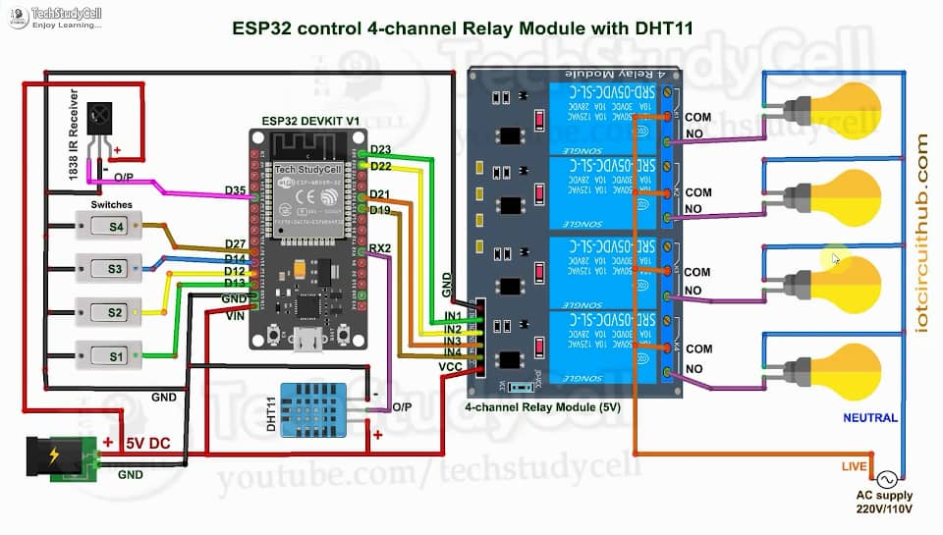

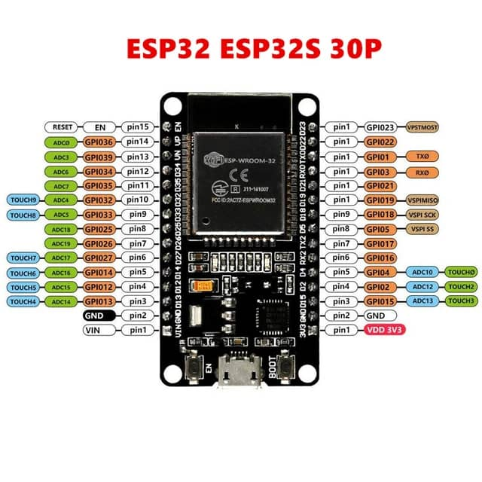

* Arduino Board: Arduino board acts as an interface between the ESP 32 and relay modules. The Arduino board receives commands from the ESP 32 and translates them into appropriate signals to control the appliances through the relay modules.

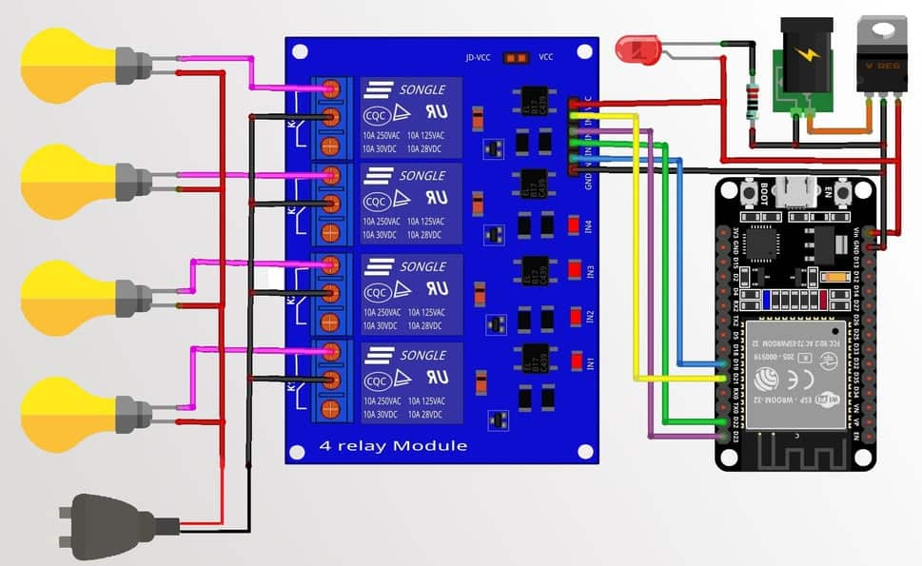

* Relay Modules: Relay modules are used to control the power supply to the appliances. They act as switches that can be controlled by the microcontroller. The relay modules are connected to the microcontroller and the appliances, allowing the microcontroller to turn the appliances on or off.

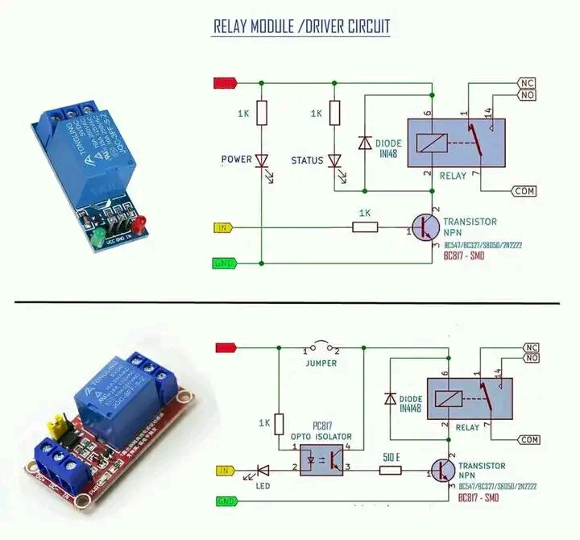

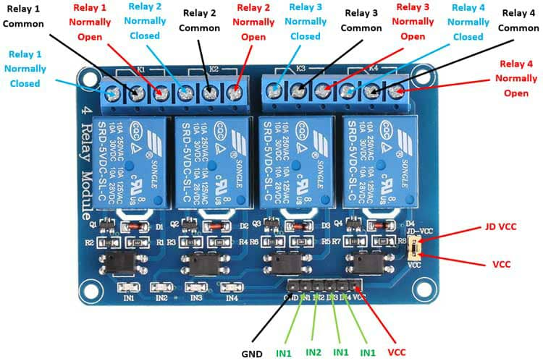

* DC Power supply (12V): A DC power supply is required to power the ESP32, Arduino board, and relay modules.
* AC Power supply 0f (12V): An AC power supply is required to power the lamps.
* Lamps: These are the devices or appliances that will be controlled remotely purposely for the demonstration of this project.
* Appliances: The actual appliances that you want to control should be compatible with the relay modules. These can include lights, fans, air conditioners, heaters etc.
* Cables and connectors. Appropriate cables and connectors to establish necessary electrical connections between the ESP32 microcontroller, Arduino board, relay modules, lamps and power supplies, ensuring proper communication and control.

3.3 Software Requirements

* Android Operating System: The android device should have an operating system compatible with the targeted android application. Ensure that the android version.
* Arduino IDE: The Arduino IDE is used for programming the Arduino board. It provides an easy-to-use interface for writing, compiling, and uploading code to the Arduino board.
* Arduino Cloud: Arduino Cloud is a cloud-based platform provided by Arduino that allows you to remotely manage and control your Arduino devices. It proves features like remote access, over-the-air updates, and data logging.
* IoT Blynk: Blynk is a popular IoT platform that provides a drag-and-drop interface for creating mobile applications to control and monitor connected devices. The Blynk is integrated with your android application to build a user-friendly interface for controlling the house appliances. Blynk provides various features to create a customized control interface and interact with the ESP32 microcontroller.

3.4 System Architecture

The architecture for the control of house appliances using android typically involves the following components:

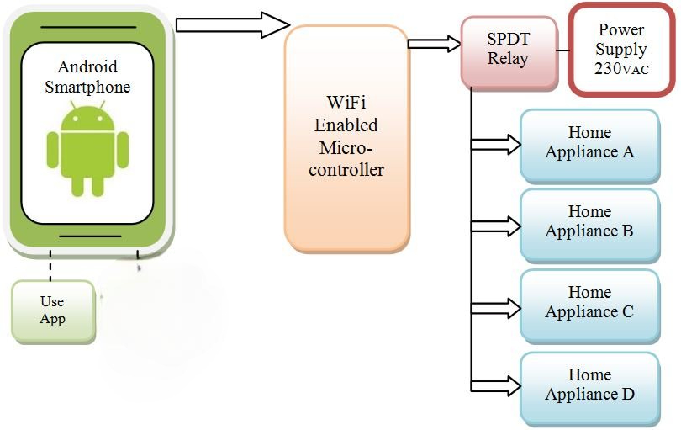

* Android Devices: The android device serves as the user interface for controlling the house appliances. It runs the android application developed for this purpose.
* Android Application: the android application is responsible for receiving user commands and sending them to the ESP32 microcontroller for appliance control. It utilizes the utilizes the android SDK, Wi-Fi APIs and user interface components to provide a user-friendly control interface.
* Wi-Fi Network: the Wi-Fi network enables communication between the android device and the ESP32 microcontroller. The android device connects to the Wi-Fi network and sends commands over it.
* ESP32 Microcontroller: The ESP32 is a powerful microcontroller with a built –in Wi-Fi capabilities. It acts as a central control unit for receiving commands from the android application and controlling the house appliances accordingly.
* Arduino Board: The Arduino board is used in conjunction with the ESP32. It serves as an interface between the ESP32 and the relay modules. The Arduino board receives commands from the ESP32 and translates them into appropriate signals to control the appliances.
* Relay Modules: Relay modules act as switches controlled by the Arduino board. They allow the Arduino board to control the power supply to the appliances, turning them on or off based on the commands received.
* Appliances: these are the house appliances that need to be controlled such as lamps and other devices. The relay modules are connected to the appliances, enabling the Arduino to control their power supply.